30/07/24

Docker dun -d -p 9000:80 {containerid} .

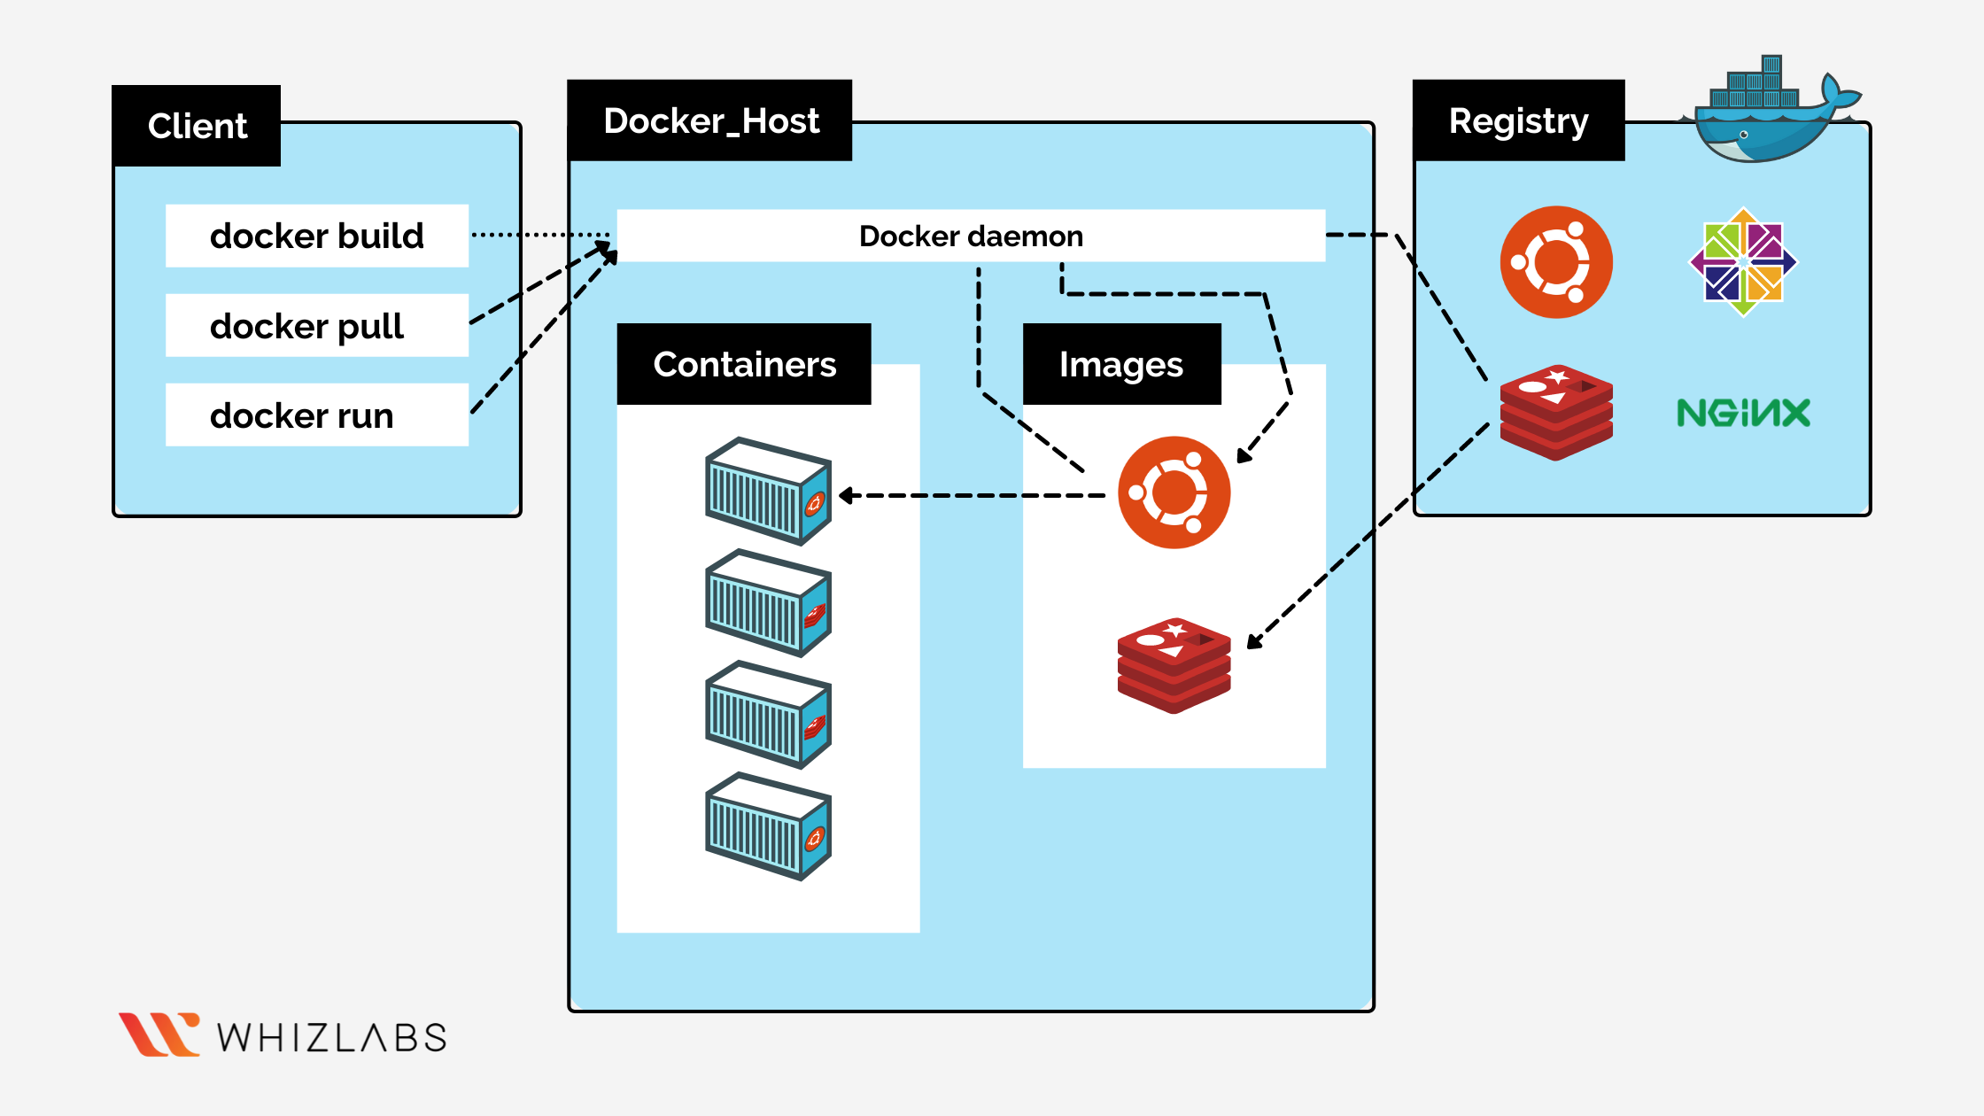

* To link the spring boot to docker:
  1. Create a docker file
  2. Add finalname in pom.xml
  3. Then maven build🡪install, then the jar is built

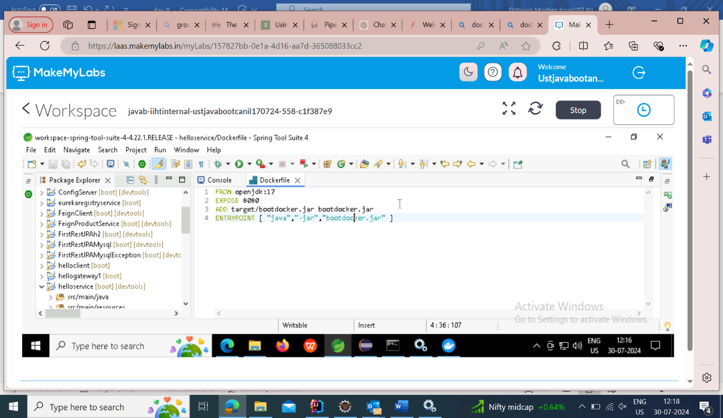

* + - In terminal;
      * docker build .
      * docker build -t docker:latest .
      * docker run -d -p 9000:{theportnumberof service in application property} docker:latest
      * Curl [http://localhost:9000/{the](http://localhost:9000/%7bthe) endpoint in controller}

Kubernetes:

Create an image of the project in docker abd then deploy it in kubernetes.

* + - Port forwarding(9090:8061)

D:\kubernets-ust>kubectl apply -f nginx-dep.yaml

deployment.apps/nginx-deployment created

D:\kubernets-ust>kubectl get deployment

NAME               READY   UP-TO-DATE   AVAILABLE   AGE

nginx-deployment   0/3     3            0           23s

D:\kubernets-ust>kubectl get pods

NAME                               READY   STATUS              RESTARTS   AGE

nginx-deployment-576c6b7b6-7t74v   0/1     ErrImagePull        0          36s

nginx-deployment-576c6b7b6-mg2h9   0/1     ImagePullBackOff    0          36s

nginx-deployment-576c6b7b6-nk5rs   0/1     ContainerCreating   0          36s

D:\kubernets-ust>kubectl get deployments

NAME               READY   UP-TO-DATE   AVAILABLE   AGE

nginx-deployment   3/3     3            3           115s

D:\kubernets-ust>kubectl apply -f nginx-serv.yaml

service/nginx-svc created

D:\kubernets-ust>kubectl get service

NAME         TYPE        CLUSTER-IP       EXTERNAL-IP   PORT(S)        AGE

kubernetes   ClusterIP   10.96.0.1        <none>        443/TCP        23m

nginx-svc    NodePort    10.108.100.149   <none>        80:30268/TCP   17s

D:\kubernets-ust>kubectl get svc -o wide

NAME         TYPE        CLUSTER-IP       EXTERNAL-IP   PORT(S)        AGE   SELECTOR

kubernetes   ClusterIP   10.96.0.1        <none>        443/TCP        24m   <none>

nginx-svc    NodePort    10.108.100.149   <none>        80:30268/TCP   41s   app=nginx

D:\kubernets-ust>kubectl get service

NAME         TYPE        CLUSTER-IP       EXTERNAL-IP   PORT(S)        AGE

kubernetes   ClusterIP   10.96.0.1        <none>        443/TCP        27m

nginx-svc    NodePort    10.108.100.149   <none>        80:30268/TCP   3m59s

D:\kubernets-ust>kubectl get deployments

NAME               READY   UP-TO-DATE   AVAILABLE   AGE

nginx-deployment   3/3     3            3           8m21s

D:\kubernets-ust>kubectl port-forward service/nginx-svc 7080:80

Forwarding from 127.0.0.1:7080 -> 80

Forwarding from [::1]:7080 -> 80

Handling connection for 7080

Handling connection for 7080

**For apache server(to get into the container and alter the index.html):**

kubectl exec -it service/apache-svc -- bash

root@apache-deployment-75444d694d-m2kmb:/usr/local/apache2# cd htdocs/

root@apache-deployment-75444d694d-m2kmb:/usr/local/apache2/htdocs# ls

index.html

root@apache-deployment-75444d694d-m2kmb:/usr/local/apache2/htdocs# cat > index.html

<html>

<head>Hello Everyone</head>

</html>

^C

root@apache-deployment-75444d694d-m2kmb:/usr/local/apache2/htdocs# exit

exit

command terminated with exit code 130

D:\kubernets-ust>kubectl port-forward service/apache-svc 7091:80

Forwarding from 127.0.0.1:7091 -> 80

Forwarding from [::1]:7091 -> 80

Handling connection for 7091

Handling connection for 7091

**nginx:usr/share/nginx/html/index.html**

